Assignment No -6

- Write a Python menu-driven program to perform the following operations on a list of numbers:
• Insert an element
• Delete an element
• Search for an element
• Display the largest and smallest element
• Display the list in reverse order
• Exit
list=[12,56,78]

def insert_list(list):
l=int(input("enter the number"))
list.append(l)
print("The list is now ",list)
def delete_list(list):
val_to_delete=int(input("enter the number"))
list.remove(val_to_delete)
return list
def searchlist(list):
i=int(input("enter the member to be searched: "))
if i in list:
print("It exists")
else:
print("It does not exist")

def display_largest(list):
print("The largest element is",max(list))
print("The smallest element is",min(list))

def reverse_list(list):
list.reverse()
print("The list after reversing is : ",list)

while True:
print("\n Main Menu")
print("1. add element to list")
print("2. delete element to list")
print("3. search the list")
print("4. Display the largest and smallest elements")
print("5. Reverse the list")
print("6. Exit")
choice=int(input("Enter your choice: "))
if choice==1:
insert_list(list)
elif choice==2:
delete_list(list)
elif choice==3:
searchlist(list)
elif choice==4:
display_largest(list)
elif choice == 5:
reverse_list(list)
elif choice==6:
break
else:
print("Invalid choice")

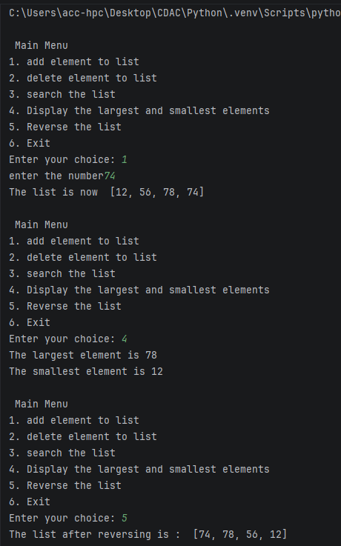
2.
Write a Python program that accepts the names and marks of 5 students and writes the details to a file named students.txt. Then read the file and display only the students who scored more than 60 marks.
students = {}
print("Enter details for 5 students:")
for i in range(5):
name = input(f"Enter name of student {i+1}: ")
score = int(input(f"Enter marks for {name}: "))
students[name] = score

file_name = "students1.txt"

with open(file_name, "w") as file:
for name, score in students.items():
file.write(f"{name}:{score}\n")

print("\n Students scoring more than 60 marks ")

with open(file_name, "r") as file:
for line in file:
name, score_str = line.strip().split(":")
score = int(score_str)
if score > 60:
print(f"{name}: {score}")

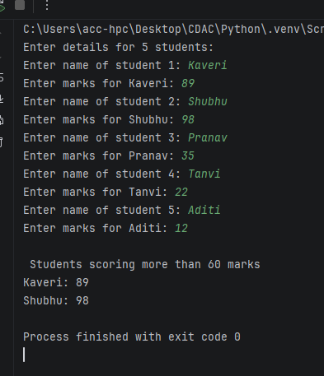
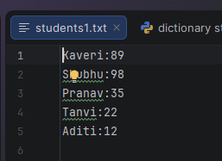
3.
Write a Python program to read a text file and count:
• Number of lines
• Number of words
• Number of characters
• Number of vowels
Display the results separately.
filename = "test.txt"
def analyze_text_file(filename):
lines_count = 0
words_count = 0
chars_count = 0
vowels_count = 0
vowels = set("aeiouAEIOU")
try:
with open(filename, 'r') as file:
for line in file:
lines_count += 1
words_count += len(line.split())
chars_count += len(line)
for char in line:
if char in vowels:
vowels_count += 1

print(f"Number of lines: {lines_count}")
print(f"Number of words: {words_count}")
print(f"Number of characters: {chars_count}")
print(f"Number of vowels: {vowels_count}")
except FileNotFoundError:
print(f"Error: The file '{filename}' was not found.")
analyze_text_file("test.txt")

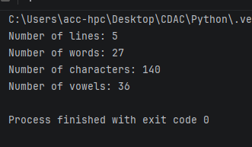

4.
Using Python's os module, write a program to:
• Display the current working directory using getcwd().
• Create a directory named Practice using mkdir().
• Change to the Practice directory using chdir().
• Display all files and directories using listdir().
import os
print('get current working directory : ', os.getcwd())
path ="C:\\Users\\acc-hpc\\Desktop\\CDAC\\Python\\Practice1"
os.mkdir(path)
#Change to the Practice directory using chdir()
os.chdir(path)
print('get current working directory after chdir() : ', os.getcwd())
print("list of file and directory")
print("Contents of 'Practice' directory:")
print(os.listdir())

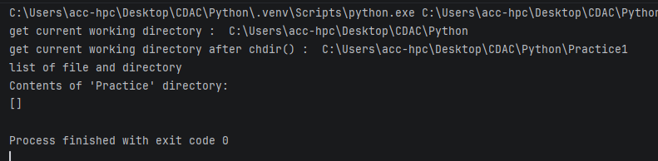
5.
Write a Python program to accept 10 integers into a list and:
• Display all even numbers.
• Display all odd numbers.
• Find the sum and average.
• Find the largest and smallest number.
• Remove duplicate elements.
list=[]
def enter_val(list):
i = 0
while i < 10:
l = int(input("Enter the number"))
list.append(l)
i += 1
print("The list is :", list)

def even(list):
even_list=[]
for i in list:
if i%2==0:
even_list.append(i)
print("The list of all even numbers is :",even_list)
def odd(list):
odd_list=[]
for i in list:
if i%2!=0:
odd_list.append(i)
print("The list of all odd numbers is :",odd_list)
def sun_avg(list):
sum=0
for i in list:
sum+=i
print("The sum of all elements in list is :",sum)
avg=sum/len(list)
print("The average of all elements in list is :",avg)

def max_min(list):
print("The maximum element in list is :",max(list))
print("The minimum element in list is :",min(list))

def unique(list):
unique_list=list(set(list))
print("The unique element in list is :",unique_list)

while True:
print("\n Main Menu")
print("1. Enter values to list")
print("2. all even numbers list")
print("3. all odd numbers list")
print("4. sum and average of list")
print("5. argest and smallest number")
print("6 Remove duplicate elements")
print("7 Exit")
choice=int(input("Enter your choice: "))
if choice==1:
enter_val(list)
if choice == 2:
even(list)
elif choice==3:
odd(list)
elif choice==4:
sun_avg(list)
elif choice==5:
max_min(list)
elif choice == 6:
unique(list)
elif choice==7:
break
else:
print("Invalid choice")

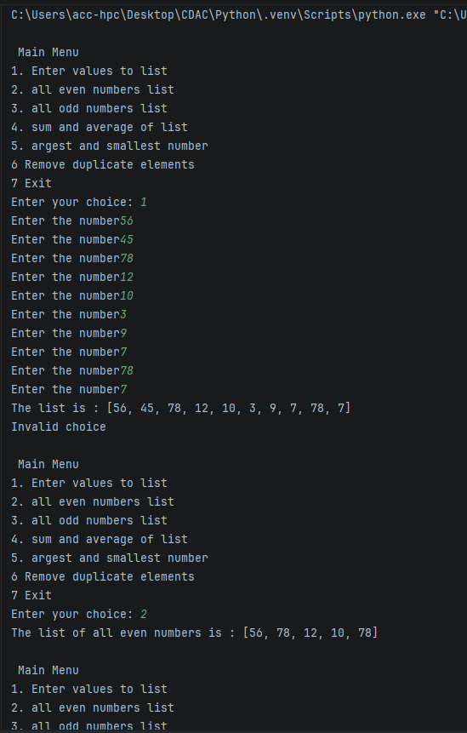

6.
Write a Python program to create a tuple containing the marks of 10 students. Using appropriate tuple operations and functions:
• Display the highest mark.
• Display the lowest mark.
• Calculate the average.
• Count how many students scored above 75.
• Search for a particular mark.
marks_tup=(56,89,92,74,65,45,58,95,99,71)
def max_marks(marks_tup):
print("The highest marks is :",max(marks_tup))
def min_marks(marks_tup):
print("The lowest marks is :",min(marks_tup))
def avg_marks(marks_tup):
print("The average Marks is :",sum(marks_tup)/len(marks_tup))
def count_distinction(marks_tup):
count=0
for marks in marks_tup:
if marks>=75:
count+=1
print("Number of students scored above 75 : ", count)
def search_marks(marks_tup):
mark=int(input("Enter the marks of student :"))
if mark in marks_tup:
print(f"Success: {mark} exists in the list ")
else:
print(f"Fail: {mark} does not exist in the list")

while True:
print("\n Main Menu")
print("1. Get highest mark")
print("2. Get lowest mark")
print("3. Get the average marks")
print("4. Count of students scored above 75.")
print("5. Search for a particular mark")
print("6. Exit")
choice=int(input("Enter your choice: "))
if choice==1:
max_marks(marks_tup)
elif choice == 2:
min_marks(marks_tup)
elif choice==3:
avg_marks(marks_tup)
elif choice==4:
count_distinction(marks_tup)
elif choice==5:
search_marks(marks_tup)
elif choice==6:
break
else:
print("Invalid choice")

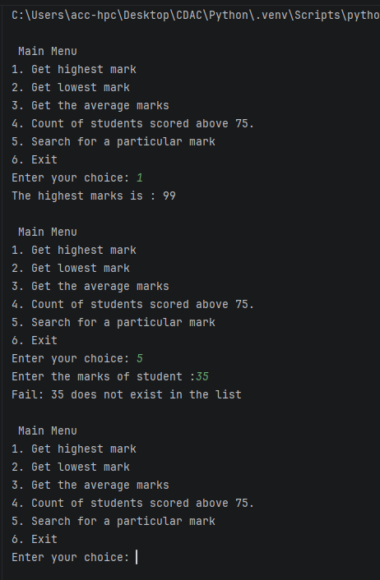
7.
Create two sets representing students enrolled in Python and Java courses.
Write a program to display:
• Students enrolled in both courses.
• Students enrolled only in Python.
• Students enrolled only in Java.
• Students enrolled in either course.
• Students enrolled in neither course, given a separate set containing all students.
all_student={"Kaveri","Punam","Aachal","Tanvi","Amit","Pranav","Sahil","Snehal"}
Python_student={"Kaveri","Tanvi","Sahil","Amit"}
java_student={"Punam","Pranav","Kaveri","Snehal"}

print(f"All Registered Students : {all_student}")
print(f"Python Students : {Python_student}")
print(f"Java Students : {java_student}")

both_courses = Python_student & java_student
only_python = Python_student - java_student
only_java = java_student - Python_student
either_course = Python_student | java_student
neither_course = all_student - either_course

print(f"Enrolled in BOTH courses : {both_courses}")
print(f"Enrolled ONLY in Python : {only_python}")
print(f"Enrolled ONLY in Java : {only_java}")
print(f"Enrolled in EITHER course : {either_course}")
print(f"Enrolled in NEITHER course : {neither_course}")

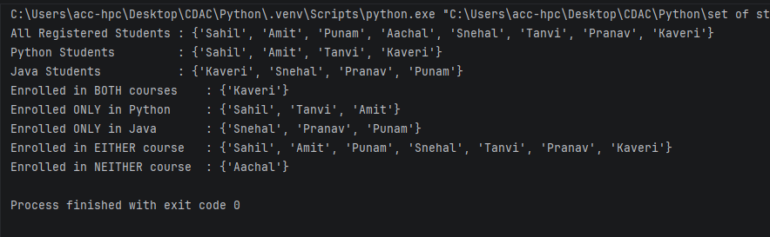
8.
Write a Python program to accept a sentence from the user and:
• Count vowels.
• Count digits and spaces.
• Display the number of words.
• Display the sentence in reverse.
• Check whether the sentence is a palindrome after ignoring spaces and case.
sentence=input("Enter sentence : ")
# Count vowels.
vowels="aeiouAEIOU"
vowel_count=0
for letter in sentence:
if letter in vowels:
vowel_count+=1
print("Number of vowels:", vowel_count)

# Count digits and spaces.
digits="0123456789"
digits_count=0
for char in sentence:
if char in digits:
digits_count+=1
print("Number of digits:", digits_count)

# Display the number of words.
word_count = len(sentence.split())
print("Number of words:", word_count)

# Display the sentence in reverse.
rev=sentence[::-1]
print("Reversed sentence:", rev)

# Check whether the sentence is a palindrome after ignoring spaces and case.
new_sentence=sentence.replace(" ","").lower()
if new_sentence==new_sentence[::-1]:
print("sentence is a palindrome")
else:
print("sentence is not a palindrome")

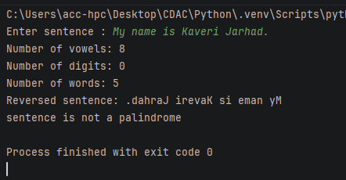
9.
Create a dictionary containing student names and their marks.
Write a program to:
• Add a new student.
• Update an existing student's marks.
• Delete a student.
• Search for a student.
• Display students who scored above 75.
• Display the student with the highest marks.
students = {
"kaveri": 82,
"pooja": 65,
"sai": 91,
"rani": 74,
"swati": 88
}
print("student records:", students)

students["shubhangi"] = 78
print("\nAfter adding shubhangi:", students)

students["pooja"] = 85
print("After updating pooja marks:", students)

del students["sai"]
print("After deleting sai:", students)

search_name = "swati"
if search_name in students:
print(f"\nSearch Result: {search_name} scored {students[search_name]}")
else:
print(f"\nSearch Result: {search_name} not found")

print("\nStudents scoring above 75:")
for name, marks in students.items():
if marks > 75:
print(f"- {name}: {marks}")

highest_student = max(students, key=students.get)
print(f"\nHighest scorer: {highest_student} ({students[highest_student]} marks)")
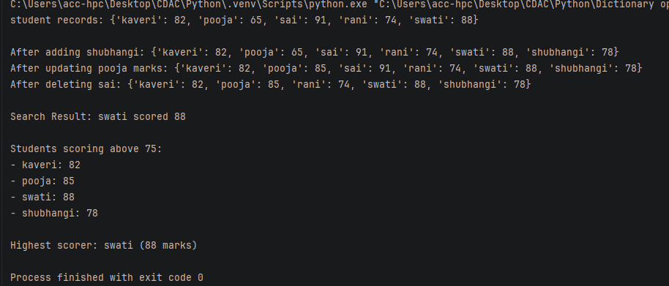
10. Check whether a file is file or directory
from pathlib import Path

path = Path(r"C:\Users\acc-hpc\Downloads\data.txt")

if path.is_file():
print("It is a file.")
elif path.is_dir():
print("It is a directory.")
else:
print("The path does not exist.")

